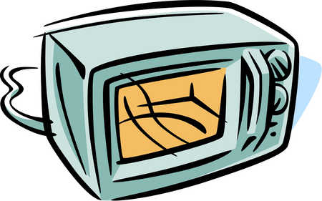
Margie was heating her food in the microwave. As she watched it spin around, she wondered where the heat was coming from. She asked several of her friends and this is what they said:

Julianna: “I think microwaves themselves are heat and the microwave oven puts heat into the food.”

DeShawn: “I think one type of energy can only turn into one other type of energy and electricity going into the microwave turns into heat”

Alonso: “I think microwave ovens receive electrical energy and then electrical energy is transferred and transformed into other forms of energy. I think the food molecules get some of that energy and start rubbing together until there is so much friction the food gets hot.”

Rebekah: “I think its Radiation”

Who do you agree with and why?
__________________________________________________________________________________________________________________________________________________________________________________________________________________________________________________________________________________________________________________________________________________________________________________________________________________________________________________________________________________________________________________________________________________________________________________________________________________________________________________________________________

