Modeling Sexual vs. Asexual Reproduction
TIME: 120 minutes over a week
ESSENTIAL QUESTIONS: How does sexual reproduction create offspring that are genetically unique? How can we use a model to understand and explain this concept?
EXPECTATIONS: Your goal is to develop and use a model to describe why asexual reproduction results in offspring with identical genetic information and sexual reproduction results in offspring with genetic variation. You should go in order and make choices for how to demonstrate your understanding when appropriate. Text in purple indicates questions to be answered and sent to your teacher and/or data that should be collected by teachers.

PART 1 (20-30 minutes) – Comparing Asexual & Sexual Reproduction
Warm Up/Review: In the inheritance Gizmo, you were able to create alien babies made from 1 parent vs. alien babies made from 2 parents.
Q1: What did you notice?
Q2: What was the same or different about both kinds of reproduction?
Activity: Choose 1 activity below:
- Choice A: Read the Article on Actively Learn – Asexual vs. Sexual Reproduction. Read the article, and answer the questions, watching the video clips that are embedded. When finished, write a short summary of each type of reproduction and be able to give an example of organisms that perform this type of reproduction. (see linked document). Turn in this work to your teacher.
- https://read.activelylearn.com/#teacher/reader/authoring/preview/523086/notes
**If the link does not work the assignment may be found in the District Library > Secondary Science > 7th Grade

- Choice B: Complete the web-based activity called “Reproductive Strategies of Organisms” (see linked document) Turn in this work to your teacher.
- If you have extra time, try these other OPTIONAL resources:
  - Interactive: https://learn.genetics.utah.edu/content/basics/reproduction/
  - Amoeba Sisters video: https://www.youtube.com/watch?v=fcGDUcGjcyk&list=PLwL0Myd7Dk1FVxYPO_bVbk8oOD5EZ2o5W
  - Interactivehttps://lsintspl3.wgbh.org/en-us/lesson/midlit10-sci-splrepro/9

Part 2 (20-30 minutes) – Learn Genetics Vocabulary
Watch any of the clips and interactives to learn vocabulary and answer the questions listed below.
- Genetics by Brainpop: https://www.brainpop.com/health/geneticsgrowthanddevelopment/genetics/
- 2 minute classroom – Genes vs. Alleles: https://www.youtube.com/watch?v=F09kUKWSvAQ
- 2 minute classroom – Dominant & Recessive Alleles: https://www.pbslearningmedia.org/resource/hew06.sci.life.gen.dominantgene/some-genes-are-dominant/
- Dominant and Recessive Interactive (you must open in Internet Explorer): https://www.pbslearningmedia.org/resource/hew06.sci.life.gen.dominantgene/some-genes-are-dominant/
QUESTIONS:
- What is an allele?
- What is a dominant allele? How do we model a DOMINANT allele?
- What is a recessive allele? How do we model a RECESSIVE allele?
- Apply this vocabulary to eye color. What must have happened for a person to have blue eyes?

If you have extra time, try these other OPTIONAL resources:
- 2 minute classroom – Heterozygous and Homozygous Alleles: https://www.youtube.com/watch?v=D8Nu3Aw6F2A
- 2 minute classroom – Genotype vs. Phenotype - https://www.youtube.com/watch?v=lYAHx7NiF3g
- Amoeba Sisters – Alleles & Genes: https://www.youtube.com/watch?v=pv3Kj0UjiLE

Also Consider:
- What is the difference between genotype and phenotype?
- What is the difference between homozygous and heterozygous?

Part 3 (15-20 minutes) – Punnett Squares
Watch any of the clips and interactives to learn how to use Punnett Squares to model inheritance between two parents.
- Heredity by Brainpop: https://www.brainpop.com/science/cellularlifeandgenetics/heredity/
- 2 minute Classroom – Punnett Squares: https://www.brainpop.com/science/cellularlifeandgenetics/heredity/worksheet/
- Gregor Mendel’s Punnett Squares – Discovery Video: https://www.youtube.com/watch?v=d4izVAkhMPQ
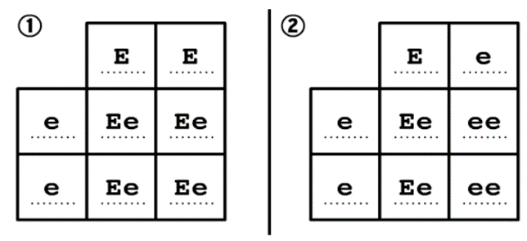
Then, complete the Brainpop Activity on Earlobes – see linked document (or below)
Tom and Alice are the parents of four children. Tom has earlobes that are not attached to the side of his head, which is a dominant trait. Alice has earlobes that are attached, which is a recessive trait. Use the two Punnett squares ("E" represents the dominant earlobe gene, and "e" represents the recessive earlobe gene) to answer the following questions.
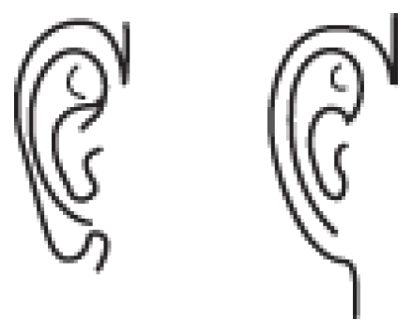
- What must be true about the earlobes of Tom's parents?
- What must be true about the earlobes of Alice's parents?
- Which Punnett square allows for the possibility that Tom and Alice's children have attached earlobes?
- What is the likelihood that the children in square 1 will have earlobes that are not attached?
- What is the likelihood that the children in square 2 will have earlobes that are not attached?
- Think About It - What does probability have to do with heredity?

If you need extra help, or have extra time, try these other OPTIONAL resources:
- Video Review: https://www.youtube.com/watch?v=znWCgqlC-s8
- TEDED - https://www.youtube.com/watch?v=Mehz7tCxjSE
- Punnett Squares Interactive: http://www.zerobio.com/drag_gr11/mono.htm
- Try a Quiz: http://glencoe.mheducation.com/sites/0078778066/student_view0/chapter5/math_practice.html
- SpongeBob Genetics: http://www.bioeyes.org/teachers/activities/inter/spongebob-genetics.pdf

Part 4 (40 minutes) – Apply Genetics Vocabulary & Concepts to Model Inheritance
You have a choice of projects:
Mouse Genetics Gizmo (see linked document) – Use the interactive simulation to breed mice. Practice writing genotypes and understanding the connection to phenotypes. Use Punnett squares to predict the offspring of two parents. Then, use the simulation to breed the mice. Do your results match your predictions? Turn your work in to your teacher.
Design-a-Kid (see linked documents: Document 1 / Document 2)– Use a coin to determine the genotype of traits that a ‘kid’ inherits from two parents. Use your understanding of dominant/recessive to translate that into phenotype – then draw your ‘kid’s face. Share your data table and your drawing with your teacher.

