PART 2
Complete this data table by looking for patterns during each 100 million year time period.
PATTERNS | 300 Million Years Ago (Red) | 200 Million Years Ago (Yellow) | 100 Million Years Ago (Green) | Present Day (Blue)
What patterns do you notice in the fossils on the continents?
Which continents had similar fossils?
From this fossil evidence, which continents seem to have been connected during this geological time?

PART 3
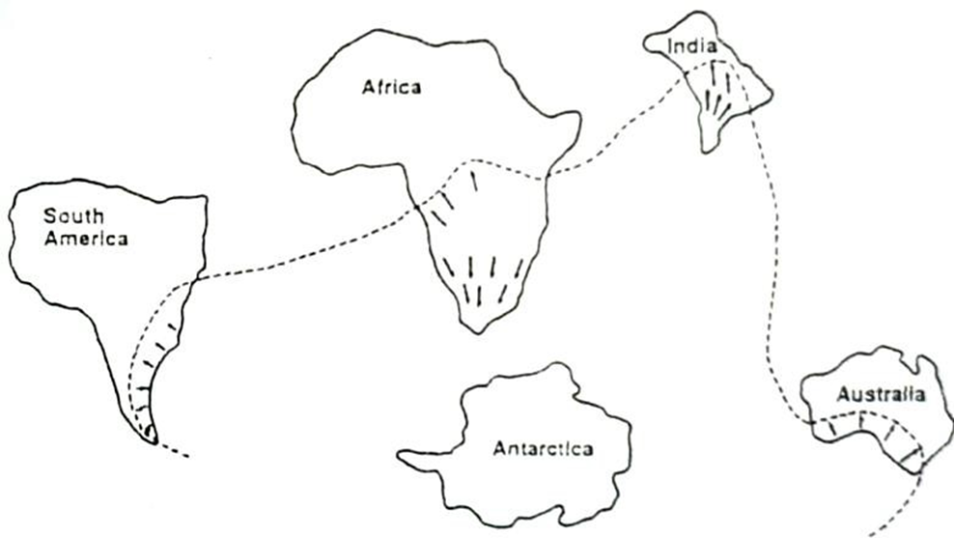
The black arrows represent grooves in the rock. The grooves were carved by advancing glaciers about 300 million years ago. The arrows point in the direction the glaciers were moving. *Mark an X on the map where you think the main glacier existed when all of these continents were connected.
PART 4
Provide 4 pieces of evidence you have gathered that support the theory of Continental drift.
- __________________________________________________________________
- __________________________________________________________________
- __________________________________________________________________
- __________________________________________________________________

