Starfish Disease
A new study shows warmer ocean temperatures are likely responsible for the mass die-off, threatening the biodiversity of marine life from Alaska to Mexico.
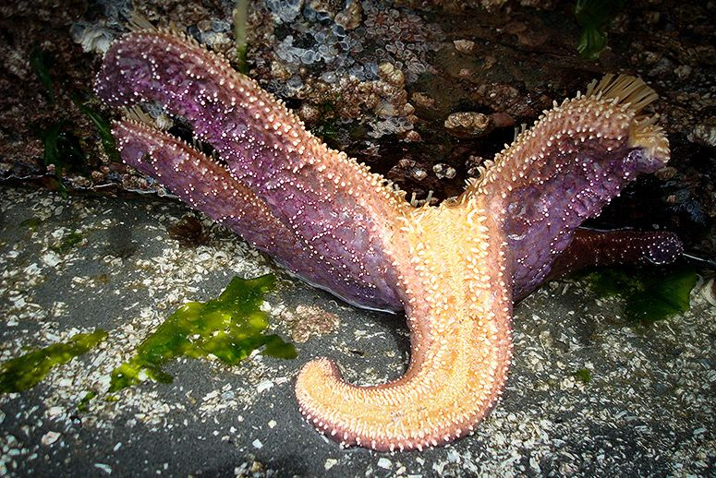
A sea star suffering from sea star wasting disease. (Photo: Alison Leigh Lilly/Flickr)
An epidemic swept across North America’s West Coast three years ago, but most people hardly noticed.
That’s because the disease targeted starfish—millions of starfish.
From Alaska to Baja California, starfish populations have been decimated by sea star wasting syndrome, a disease that turns the darlings of the tide pool world into heaping piles of goo within days of exposure.
Scientists have observed wasting events hitting coastal starfish populations before, but nothing like this epidemic, which researchers are calling the single largest, most geographically widespread marine disease ever recorded.
Sea stars, or starfish, are what’s known as a keystone species, important to maintaining biodiversity in marine environments. But an epidemic that swept across the West Coast killed millions of the multi-limbed animals—wiping out up to 95 percent of populations in some regions. Now, a new study is showing warming ocean temperatures might make mass die-offs more severe.
Without starfish to keep mussel populations in check, the sharp-shelled bivalves would push out other marine species, damaging the biodiversity of habitats along the West Coast.
RELATED: Starfish Are Not the Wallflowers You Think They Are
“Warmer water temperatures might not have been the catalyst for the disease, but our findings show that if the water hadn’t been so hot that year, the impact would most likely have been less,” said Drew Harvell, study coauthor and a professor of ecology and evolutionary biology at Cornell University.
For the study, researchers looked at the ochre sea star. The species is the West Coast’s most prevalent starfish, known for its purple or orange coloration, five-limbed body, and voracious appetite for mussels.
The team analyzed water temperature records taken before, during, and after the wasting episode at locations around the San Juan Islands and Puget Sound in Washington state. They found that as water temperatures rose across the region, so did the risk of infection for sea stars. Sites where water temperatures rose the most left sea stars at highest risk of infection.
Researchers also placed sea stars in aquarium tanks set to temperatures ranging from 54 degrees to 66 degrees Fahrenheit. The hotter the tank, the more quickly starfish succumbed to wasting, Harvell said.
“That confirmed that water temperature can affect mortality,” she said.
With ocean temperatures steadily increasingthanks in part to human-induced climate change, the future of sea stars could be threatened.
The sheer size of this latest wasting event has scientists concerned. Melissa Miner, a marine biologist at the University of California, Santa Cruz, said sea star populations are still decimated across nearly all of the West Coast.
“We’ve got about nine sites, out of the 70 or so we monitor between Washington, Oregon, and California, where we have seen good recruitment of baby sea stars coming back,” Miner said. She’s cautiously optimistic that those nine sites could be the source populations that help reestablish sea stars in regions still decimated by the disease.
But in Southern California, sea star survival has been low. Miner said no sites south of Point Conception are showing much improvement.
On a walk amid tide pools in Newport Beach’s Crystal Cove State Park last week, this reporter did not spot a single starfish. In October 2014, scientists found 191 starfish along the same rocky reef. Now, there appeared to be an abundance of mussels lining the rocks—the ochre starfish’s favorite meal.
“We don’t have the data yet to back this up, but my gut feeling is that we’ll see an increase in mussel cover across many sites—especially in the lower intertidal zones where they are typically controlled by sea stars,” Miner said.
With the study findings limited to a small region of starfish, Harvell wouldn’t hypothesize what climate change might mean for the species, but she said it would be better for all starfish in the region if the water got cold, quick.
“Alaska is where the action is now,” Harvell said. “They’re experiencing incredible warm temperature anomalies in the northernmost range, and that’s the next region to see how sea stars react there.”

